**MBA 590 – Strategic Leadership & Management Capstone**

**Growth Plan**

**Growth Plan Template – Part 1: Where are you?**

**Company's Name: Coursera**

**Mission Statement: Our mission is to provide universal access to world-class learning so that anyone, anywhere has the power to transform their life through learning.**

**Key Stakeholders**

* **Examples of External Stakeholders:** educators, learners, organizations, institutions
* **Examples of Internal Stakeholders:** employees, stockholders, board members

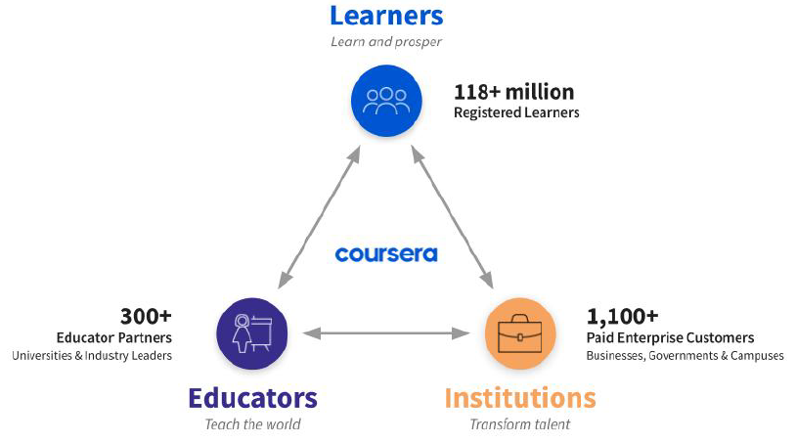

< Coursera’s global learning ecosystem as of December 31, 2022 >

### Company's History and Organization's Life Cycle

* **Company’s History:** Coursera was founded in 2012 by Stanford University computer science professors Andrew Ng and Daphne Koller. Ng and Koller started offering their Stanford courses online in fall 2011, and soon after left Stanford to launch Coursera. [Princeton](https://en.wikipedia.org/wiki/Princeton_University), Stanford, the [University of Michigan](https://en.wikipedia.org/wiki/University_of_Michigan), and the [University of Pennsylvania](https://en.wikipedia.org/wiki/University_of_Pennsylvania) were the first universities to offer content on the platform.

In 2014, Coursera received both the Webby Winner (Websites and Mobile Sites Education) and the People’s Voice Winner (Websites and Mobile Sites Education) awards.

Today, Coursera is a global platform for online learning and career development that offers anyone, anywhere, access to online courses and degrees from leading universities and companies. Coursera received B Corp certification in February 2021, which means that Coursera has a legal duty not only to its shareholders, but to also make a positive impact on society more broadly, as Coursera continues its efforts to reduce barriers to world-class education for all.

* **Company’s Funding History:** Coursera raised an initial $16 million funding round backed by Kleiner Perkins Caufield & Byers and New Enterprise Associates.   
  In 2013, [GSV](https://en.wikipedia.org/w/index.php?title=GSV_Asset_Management&action=edit&redlink=1) led the [Series B](https://en.wikipedia.org/wiki/Series_B_funding) investment, which totaled $63 million. In 2015, NEA led the Series C round of venture funding, which totaled more than $60 million.  
  In 2017, the company raised $64 million from its existing investors in a Series D round of funding. In 2019, the company raised $103 million in Series E round of funding from the SEEK Group, Future Fund and NEA.  
  The company reached valuation of $1 billion+ in 2019. In July 2020, the company announced it had raised $130 million in Series F funding and updated its valuation to $2.5 billion.
* **Company’s Financial History:** Coursera's revenues rose from $184 million in 2019 to $294 million in 2020. To date, Coursera has not made a profit. The company lost $66 million in 2020 as it ramped up marketing and advertising.  
  Coursera incurred net losses of $175.4 million, $145.2 million, and $66.8 million in the years ended December 31, 2022, 2021 and 2020, respectively, and Coursera had an accumulated deficit of $664.1 million and $488.8 million as of December 31, 2022, and 2021, respectively.  
  Despite the explosive increase in demand for online education due to COVID-19, Coursera has never been in the red in the past four years.

< Coursera’s annual Revenue and Earnings from 2019 to 2022 >

**Culture and Human Capital Resources**

* **Overview:** Coursera created a system of equitable employee services and workplace experiences to help employees perform at their best and to deliver the company’s mission of transforming lives through learning.  
  As of December 31, 2022, 1,401 full-time employees make up a global community that is driven by a shared purpose and transformative impact. The team also engages contractors and consultants for auxiliary services and support.  
  Coursera’s focus on building a great place to work has resulted in a strong culture that values innovation and results at scale. The employees are proud to work at Coursera and of the positive social impact that the company can make together. To further enable Coursera’s ability to grow and fulfill the public benefit objectives, Coursera continues to invest in attracting, retaining, and developing team members while enhancing diversity and inclusion in company’s workforce.
* **Diversity, Equity, and Inclusion (DEI):** Building a more diverse workforce powers Coursera’s ability to deliver on the company's mission: it fuels the performance and innovation Coursera needs to provide universal access to world-class learning, and it inspires collaboration to help the company create inclusive learning alongside our university and industry partners and Enterprise customers.  
  At Coursera, employees strive to promote a culture of continuous learning and improvement. For the last ten years, Coursera has measured employee engagement and tracked employees’ perspectives on important issues through the employee pulse surveys. The participation rate continues to be high, at 97% for 2022. Employee pulse survey results provide important insight into organizational health and allow the company to address opportunities for improvement in more focused and meaningful ways.  
  Coursera’s DEI initiatives and programs also strengthen the company’s workplace culture and support talent acquisition and retention goals. Coursera supports the DEI strategies to enhance workplace diversity, promote cross-cultural learning, and advance the company’s ongoing efforts to build a company where everyone can thrive.

**Organizational Design (add organization chart if available)**

Some guiding questions –depending on the sources you can find—:

* Would you estimate the company has a high or low power distance? i.e., the distribution of power in the organization. For example, at the organizational level, is the power concentrated in a few managers/teams? You can also take a more objective look at the resource allocation to each division, are the resources (number of people, investment levels of each division, division manager pay) evenly distributed throughout the organization, or are they concentrated?
* The concept at the Team Level: “High power distance teams are ones in which the leader has clear authority and a low power distance team is one in which the power is more equally distributed among the team members. In this study, the researchers found that teams from a high power distance culture were more likely to reach the top of the mountain, but we're also more likely to have people die along the way” (Leading Teams, Coursera Lectures).

**Current Leadership:**

Profiles of current top managers, Status & Power, Style, and DEI (Diversity, Equity & Inclusion) leadership efforts. Sources: You can try to find profiles in media and the shareholders' reports, or interviews the managers have given.

**Growth Plan Template – Part 2: What do we do best? (Nam)**

To better understand what Coursera as a company does best we’re going to use VRI framework to analyze the current company's sources of competitive advantages.

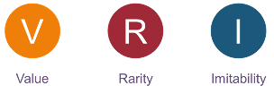

***Three*** *resources and/or capabilities that are important for Coursera:*

* *Key Resource/Capability #1: The company’s present scale*
* *Key Resource/Capability #2: Quality education with attractive price-to-cost*
* *Key Resource/Capability #3: Huge data base of learners’ behavior and paths*

|  |  |  |  |
| --- | --- | --- | --- |
| **Resource / Capability** | ***Valuable*** | ***R****are* | ***Costly to Imitate*** |
| *Key Resource/Capability #1:* ***The company’s present scale*** | ***Y*** | ***Y*** | ***Y*** |
| *Key Resource/Capability #2:* ***Quality education with attractive price-to-cost*** | ***Y*** | ***Y*** | ***Y*** |
| *Key Resource/Capability #3:* ***Huge data base of learners’ behavior and paths*** | ***Y*** | ***Y*** | ***Y*** |

Now let us look into the details of each Key Resource/Capability in detail.

* **Key Resource/Capability #1: The company’s present scale**

Coursera reached 82 million registered learners in Q1 2021. This online learning platform offers education to individual learners around the world, students on campus, employees from governments and enterprises. 51% of Coursera revenue is outside of the United States.

**For Business and Enterprise**:

Aside from courses for learners, Coursera also has Enterprise business consisting of three verticals:

* Coursera for Business with 2000 businesses, a quarter of which is Fortune 500 companies like Amazon, Google
* Coursera for Campus partnering over 200 prestigious universities.
* Coursera for Governments with more than 100 government agencies and organizations around the world

**For Degree**:

Coursera started first online degree with Illinois’ iMBA in 2015. Since then, Coursera has grown to 26 online degrees from 13 university partners with about 12,000 students worldwide.

**For Government**:

Coursera partners with about 350 government agencies to give training to 750,000 learners.

A huge number of learners both free and accredited allows Coursera to leverage its enormous, trusted and verified data to suggest paths for job skills in Coursera’s Skill Graphs, for example, which is valuable for learners in upgrading their skills for job finding.

Trust from government agencies, giants like Amazon, Google, S&P, Hewlett-Packard or prestigious universities like University of Illinois, University of Colorado Boulder, University of London … takes time to build which is hard for Coursera’s competitors to imitate.

* **Key Resource/Capability #2: Quality Education with attractive price-to-cost**

Coursera is one of the most disruptive firms in the world. The edu-tech platform efficiently acquires learners at scale because of the huge number of free, high-quality courses that it offers in partnership with top educational institutions and corporations. Together with the quality and reputation it has been building around its offerings, its price-to-cost is another advantage it has versus its competitors. Some Coursera courses are free, but the vast majority aren’t:

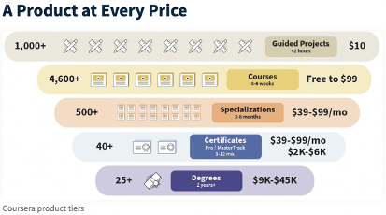

- Guided projects start at $9.99 per month.

- Professional certificates at $39 to $99 a month, where learners can partake in more than 500 specifications to gain job-relevant skills in 3 to 6 months, they can even get professional certificates.

- Master Track certificates start at $2,000.

- Degree courses are ranging from $9,000 to $45,000

According to Coursera, its average student acquisition cost is less than $2,000 which is lower than industry standard.

Top 5 Coursera competitors are Udemy, edX, Skillshare, Udacity and Alison:

- Udemy offers both free and paid courses, but it doesn’t offer accredited programs

- edX too offers both free and accredited programs partnering with top universities like Harvard, MIT, Berklee College of Music, University of California, Berkeley. edX focuses on higher education.

- Skillshare focuses on professional development non-accredited courses with hands-on approach.

- Udacity is ten times smaller than Coursera that offers free and accredited courses partnering university and businesses that focus on technology education.

- Alison offers both accredited and non-accredited courses. It partners with universities and organizations to offer free certification in various subjects. Alison is smaller than Coursera however, Alison’s many free courses and its focus on employability give it a competitive advantage.

Coursera uses technology to drive down distribution costs, make content more affordable, provide access to less economically endowed regions, help learners keep abreast of emerging skills, and grow its market opportunity. The Covid-19 pandemic has only accelerated secular trends towards the use of technology in education. That said, with the analysis above, quality education with attractive price-to-cost is not really Coursera’s sustainable competitive advantage, but it has the advantage of being ahead of the game compared to its competitors. It takes time and money for them to catch up.

* **Key Resource/Capability #3: Huge data base of learners’ behavior and paths**

Coursera offer quality education to people around the world with a mission that “education is the source of human progress”:

- 93% of Coursera learners say they would recommend the platform to their friends.

- The average rating of courses on Coursera is 4.7 out of 5.

- 99% of enrollments on Coursera rate the online course provider higher than 4.0 out of 5.

- 79% of Coursera learners have rated it 5-star.

- Three out of four learners who enroll on Coursera go on to sign up for another course.

87% of the learners on Coursera report benefits when they seek to pursue new career paths.

- 78% of learners become more confident after going through Coursera courses.

- 92% of learners intending to boost their education report benefits such as increased readiness for an exam.

With above data from 82 million registered learners, Coursera possesses huge data base of learners’ behavior and their paths which they can use to help learners improve their education plan. Coursera designs learner’s curriculum to be “stackable”, which means a learner can go through a domain in an incremental fashion. The company leverages the huge volume of data it has accumulated to personalize content. So, for example, Coursera’s Skills Graphs can suggest paths for job skills which helps learners build reliable plans for upgrading their skills which is an advantage this online platform had over its competitors.

***Step 4.*** *Determine which resources/capabilities can be a source of competitive advantage. Only those resources/capabilities that check all three boxes* ***Valuable (Yes) + Rare (Yes) + Costly to Imitate (Yes)*** *can be a source of competitive advantage. If your company does not (currently) have a clear source of competitive advantage, please discuss what can be done to create one. For example, how can you build a better value proposition, create or access rare resources, and what isolation mechanisms can you build?*

Competing in the MOOCs space is no easy feat. The market is crowded with many players, A study by Global Newswire suggests that the global MOOCs market will grow at a CAGR of 34.54% during the forecast period to reach US$7,209.889 million by 2027, from US$903.418 million in 2020. If these predictions are accurate, the market opportunity is significant, and it’s likely to attract more entrants. In the past two years, in particular, MOOCs have witnessed rapid growth owing to the emergence of multiple MOOC platforms like EdX, Udacity, Coursera, and many others, as they offered free courses from many top-tier universities. Lucky for Coursera, it established itself early on as a leader in the space. The company doesn’t just offer quality courses; it also provides certification and degree programs from accredited universities. These factors, combined with partnerships with top educational institutions, help Coursera maintain a dominant market position.

***Threats to value creation: durability, relevance***

Online education is a young market that is growing fast, which attracts entrants with no obvious dominant players just yet. Coursera has established itself as a leader with solid technology and customer base. But there are players that are working their way into this market. EdX with partnerships with the most prestigious universities, or Udemy with the believe that education belongs to each individual, not the institutions.

Coursera is dependent on partnership with e-learning providers and could be adversely affected if they are terminated.

***Threats to rarity: imitation, replication***

One of Coursera advantage is its scale, but its market share is small. Its scale can be replicate by its competitors. The same goes for quality of its courses or its possession of huge data base about learners.

Coursera has solid financial position, extensive course catalog, partnership with top universities, government agencies, top enterprises. It can continue to build on this, take the advantage of the market growth, expand its partnership with e-learning providers, launch new products, services and use technologies to make learning easier, interesting and personalized.

**Growth Plan Template – Part 3: Why are you here now?**

You may add pages/modify this template as needed. As long as the final product reflects Specialization concepts and other relevant models from your experience and sources.

Part 3 is the Executive Summary of the Growth Initiative/s you are recommending to address a 4% growth gap. You can have one or more (non-incremental) Growth Initiatives that add up to at least 4% in additional annual revenue. Here it is important to explain your estimation of the potential for revenue generation. This estimation does not need to (necessarily) be the result of a discounted cash flow analysis. You can be creative: build your case using comparable companies, multiples relevant to the (growth initiative/s’) industry, and estimated market share, among others. What is a non-incremental Growth Initiative?

* **Opportunity 1:**
* Executive Summary:
* Potential for Revenue generation ($, and as % of annual revenues):
  + Market size, profit pool

##### Opportunity 2:

* Executive Summary:
* Potential for Revenue generation ($, and as % of annual revenues):
  + Market size, profit pool

**Strategic Leadership & Management Capstone**

**P**

P

**E**

E

**T**

**E**

E

**L**

…

…

…

…

…

…

MBA 590 | Spring 2023 Sandra Corredor

# Growth Plan Template – Part 4: Where is the industry's future going?

Think about the macro-environment for implementing your Growth Initative/s. Identify critical external factors that the company needs to address when developing and implementing your proposed Growth Initiatives. Focus on developing a macro-environment (external) risk assessment for the implementation of your Growth Initative/s. For example, what factors from our current external environment favor and threaten your growth initiative/s?

**Strategic Leadership & Management Capstone**

MBA 590 | Summer 2022

Sandra Corredor

### Porter's Five Forces Analysis for the Growth Initiative/s industry

Assess industry attractiveness: build a Five Forces Analysis for your Growth Initative/s. Highly recommended source: **IBIS World**. Can be accessed from the University Library:

* + Industry Information

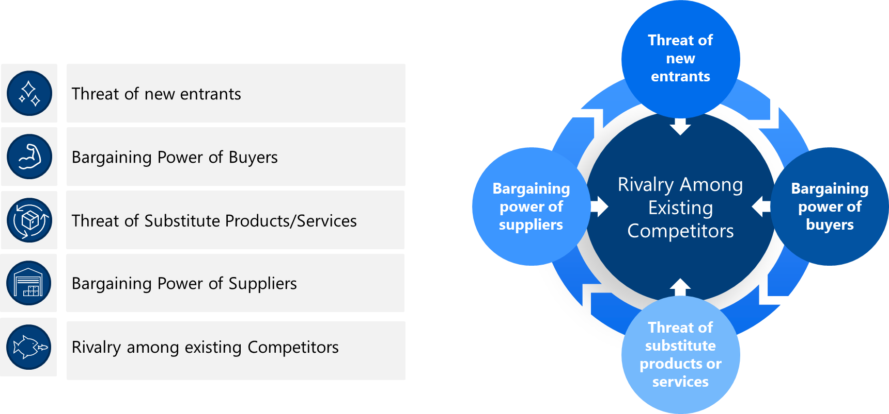

**Explain whether your Growth initiative/s industry had (or not) a Pivotal Force** *Reminder: What is a "pivotal" force?—A Pivotal Force presents the greatest threat to the industry's ability to capture profits. Increasing or mitigating this threat has a direct impact on industry profitability.*

GiesBusiness.illinois.edu | [corredo2@illinois.edu](mailto:corredo2@illinois.edu)

**Strategic Leadership & Management Capstone**

MBA 590 | Summer 2022

Sandra Corredor

# Growth Plan Template – Part 5: What do you need to do?

1. **Define your Growth Initiative/s business model (VARS).**

|  |  |
| --- | --- |
| **V**  **Value**  **Proposition** | * What serious customer problems can be solved for the consumer? Why now? – evolution of product/service category. * Sources of value: newness, performance, customization, design, brand, status, cost-effective, risk reduction accessibility, convenience, trust, price, etc. * Jobs to be done: the mechanisms and reasons that cause your customer to buy your products/services. E. . s s s s s “ ” |
| **A**  **Activities,**  **Resources, Capabilities** | * Identify key Activities, Resources and Capabilities to move forward with your Growth Initiative/s. * Resources: financial, physical, technology, relational, human capital. * Capabilities: organizational and managerial skills. |
| **R**  **Revenue Model/s** | * Unit sales, advertising fees, transaction fees, complements, subscription fees, franchise fees, professional fees, agency fees, license fees, freemium, etc. |
| **S**  **Scope of the**  **Enterprise** | * Product/Service mix (diversification): current product mix, what is in the pipeline. * Customer scope (segments) * V s s. s ’s s |

GiesBusiness.illinois.edu | [corredo2@illinois.edu](mailto:corredo2@illinois.edu)

1. **Create the Conditions for Growth**

Some relevant questions for creating the conditions for Growth include: What changes are required in policies, procedures, culture, and behaviors to help your Growth Plan? For each of the questions explained in this part, think about the top 2-3 action items.

*Some ideas:*

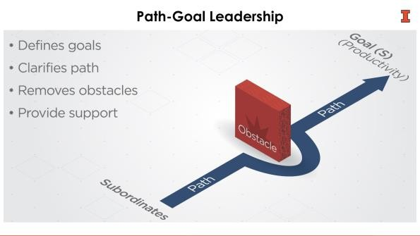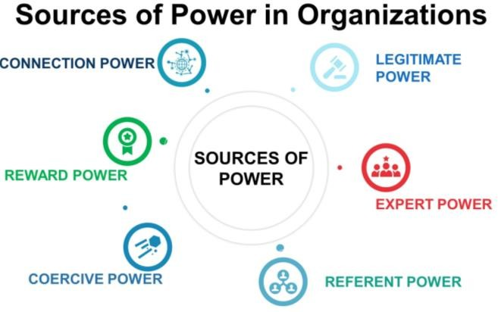

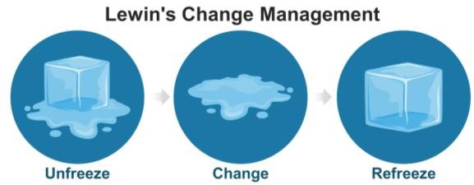

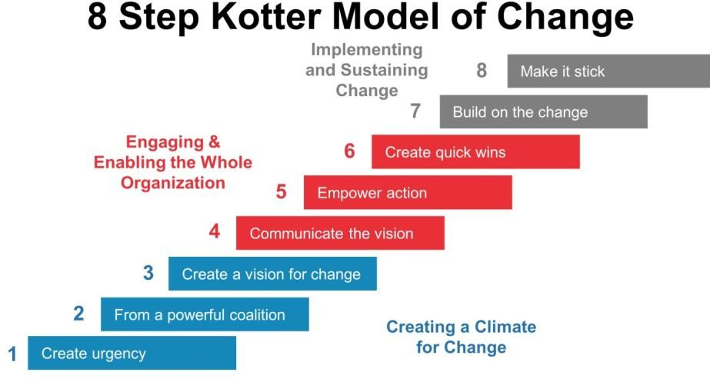

**Prioritize your stakeholders:** three levels of stakeholder engagement - inform, consult and collaborate – to support your Growth Plan.

GiesBusiness.illinois.edu | [corredo2@illinois.edu](mailto:corredo2@illinois.edu)

### Growth Initiatives: Communication and Engagement Opportunities

*List potential communication and engagement actions that can be taken to communicate the Growth Initative/s: goal status, expectations, and achievement within the Organization and its Divisions.*

### What are the most immediate needs for enhanced/new HR services and support?

*List the most immediate requests for HR services/support for your Growth Initative/s.*

### What are the related implications and suggestions for organizational structural design needed to implement your growth initiative/s?

Where will your Growth Initaitve/s be placed within your company? Who is going to monitor the Growth Plan implementation? Who will have (realistic) oversight?

**Developing an Ethical Culture for your Growth Initiative**

How would these components of Ethical Cultures (Coursera link) apply to your Growth Initiative/s:

* + Clarity
  + Congruency of supervisors
  + Congruency of management
  + Feasibility
  + Supportability
  + Transparency
  + Discussability
  + Sanctionability

### Fostering Psychological Safety

* + How would you make sure you are fostering psychological safety for your Growth Initiative/s team? Coursera link on this topic here.
  + How would you mitigate burnout in your Growth Initiative/s team? Coursera link here.

GiesBusiness.illinois.edu | [corredo2@illinois.edu](mailto:corredo2@illinois.edu)

**Strategic Leadership & Management Capstone**

MBA 590 | Summer 2022

Sandra Corredor

**Priorities for creating the conditions for Growth—** Leadership, Change Management, and Implementation, Engagement for Stakeholders. What things do we need to START doing in order to translate our Growth Plan into action? What things do we need to STOP doing in order to translate our Growth Plan into action? Finally, what things do we need to KEEP doing in order to translate our Growth Plan into action?

Start

Stop

Keep Doing

Action item

Action item.

Action item

Insert your desired text here.

Action item

Action item

Action item.

Action

item.

Action item

Action item

Action item

GiesBusiness.illinois.edu | [corredo2@illinois.edu](mailto:corredo2@illinois.edu)

1. **Leverage the Core Business**

The core businesses of your company have probably much to offer to your Growth Initiative/s. First, think about your company's current resources and how you can apply them to enhance your growth initiative's value creation and operations. Examples include R&D capabilities, relational resources, market research expertise, legal talent, payroll and overhead systems, distribution channels, etc. If appropriately applied, your organization's existing resources and capabilities can dramatically reduce the risk of building a growth initiative and the time needed for it to generate positive cash flow. Further, consider how the capabilities of the core businesses need to be adapted to serve the needs of your growth initiative/s.

* + How would your company's current capabilities (your VRI analysis) be leveraged to support your Growth Initiative/s? How would these capabilities need to be adapted for Growth?

What do we need to build (learn/develop/acquire) to be effective in this new terrain? Think about your aspirational VRI.

* + Are there risks associated with leveraging and/or building (internally or acquiring) these resources and capabilities? Keep in mind that the Descartes Square can be a useful Decision Tool to asses risks:

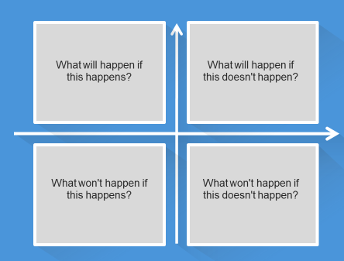

1. **Choose the right leaders for Growth**

You will consider leadership needs to support the Growth Initiative/s you have identified. We ask that you consider what you have learned about leadership competencies, and leadership roles (coaches, mentors, sponsors), among other concepts, to develop a profile for your Growth

GiesBusiness.illinois.edu | [corredo2@illinois.edu](mailto:corredo2@illinois.edu)

Initiative/s Leader. Keep in mind that your organization will need a way to measure or assess these profile characteristics, so try to be as concrete as possible.

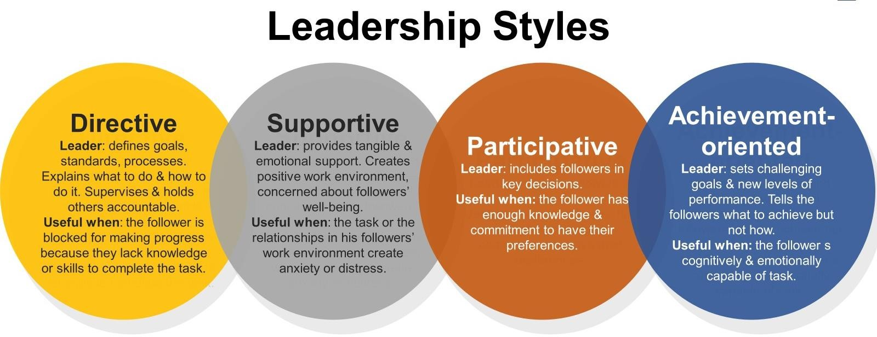

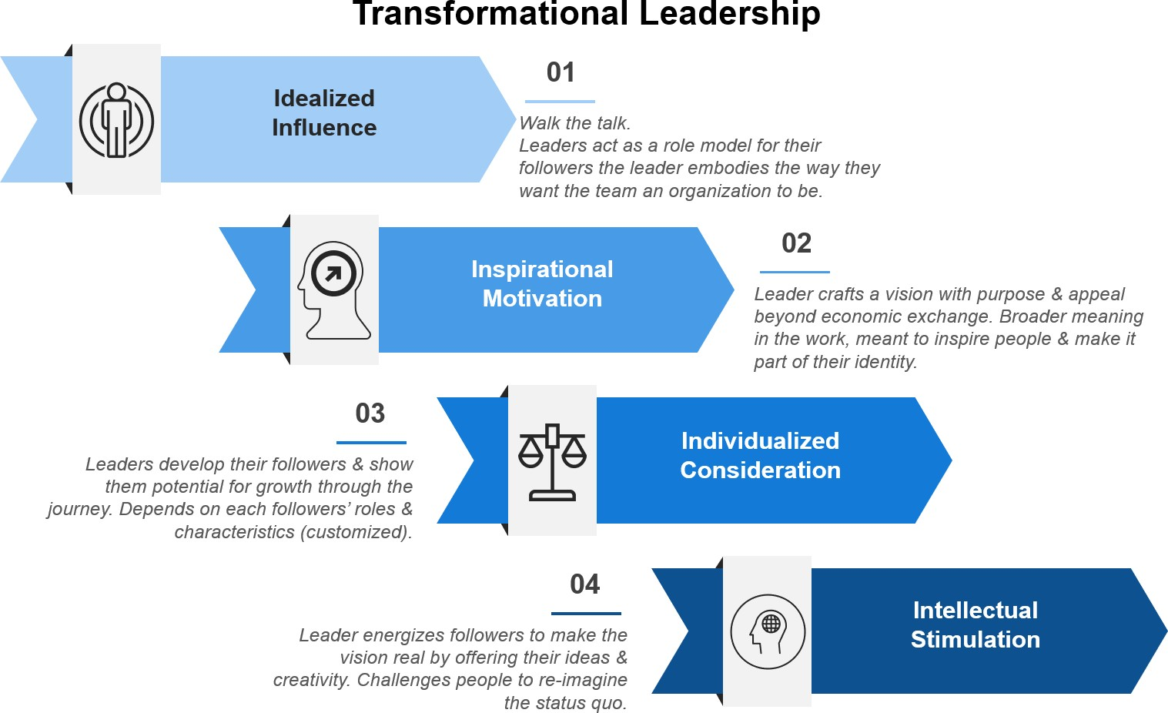

GiesBusiness.illinois.edu | [corredo2@illinois.edu](mailto:corredo2@illinois.edu)

### List of desirable attributes to select the leaders of your growth initiative/s.

Think about the attributes to select the leader for your Growth Plan. Focus on leaders' (desirable) capabilities, not on the company's immediately available people.

**Ini ia iv L ad ’ A ib**

E

s s .

U s …

E s …

K …

**Ex na pp R Ini ia iv L ad migh n d**

s s s



s…

s

s

s s s…

s s…

E I

ss

k

ss ss

’s: curiosity, courage, commitment.

## …. s s

1. **Establish the right metrics and milestones to track the growth progress** Create a balanced scorecard with specific metrics and milestones to track your Growth Plan's progress. You should include expectations for margins, revenue requirements, and practices, among other indicators. Develop four goals (as it refers to your proposed growth initiative/s) in each category: Engaged Customers, Financial Performance, Internal Processes (Operational Excellence), and Learning & Innovation. What are the critical milestones?

Consider that companies often apply the same metrics and milestones to their current and Growth businesses. After taking this specialization, you know this would be a mistake.

GiesBusiness.illinois.edu | [corredo2@illinois.edu](mailto:corredo2@illinois.edu)



How we maintain a healthy financial strategy for growth

Vision,

Goals

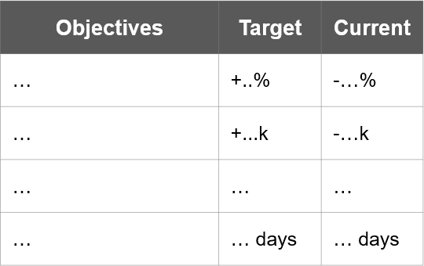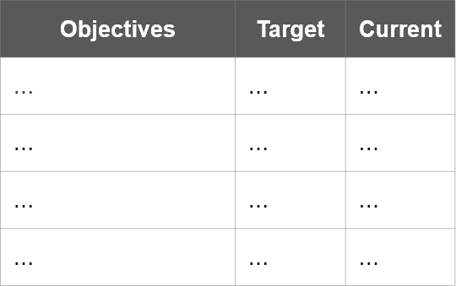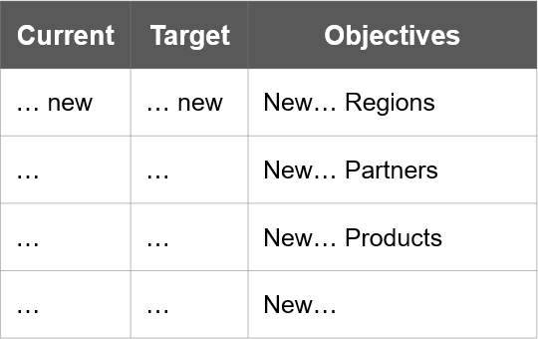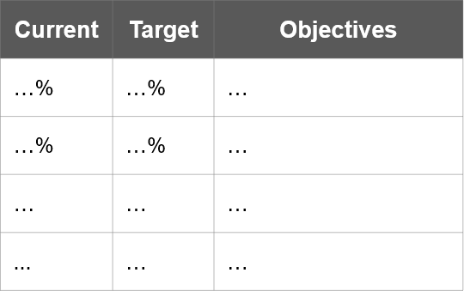

How we maintain a healthy learning and innovation approach

**Strategic Leadership & Management Capstone**

MBA 590 | Summer 2022

Sandra Corredor

Strategy

How we increase

our success

and maintain

our customer strategies

Internal initiatives and strategies designed to increase internal performance

GiesBusiness.illinois.edu | [corredo2@illinois.edu](mailto:corredo2@illinois.edu)